Lab: Limit overrun race conditions

This lab's purchasing flow contains a race condition that enables you to purchase items for an unintended price.

To solve the lab, successfully purchase a Lightweight L33t Leather Jacket.

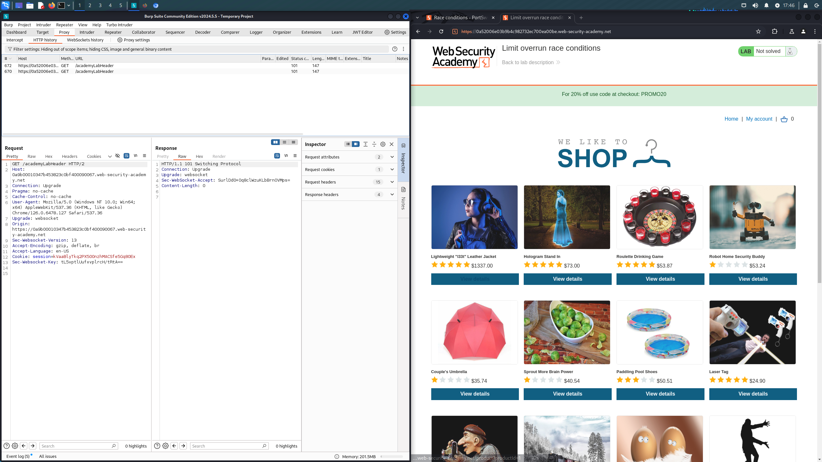

Upon accessing the lab, we can see the user has $50 but the leather jacket to purchase is $1337. You can also see there is a promo code provided which will take off 20% at checkout. Let’s examine the flow for applying the promo code and purchasing something much cheaper first.

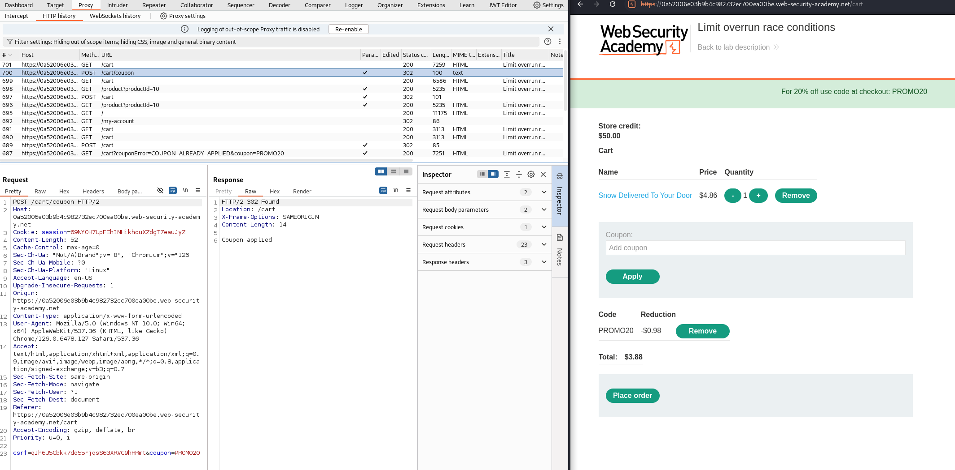
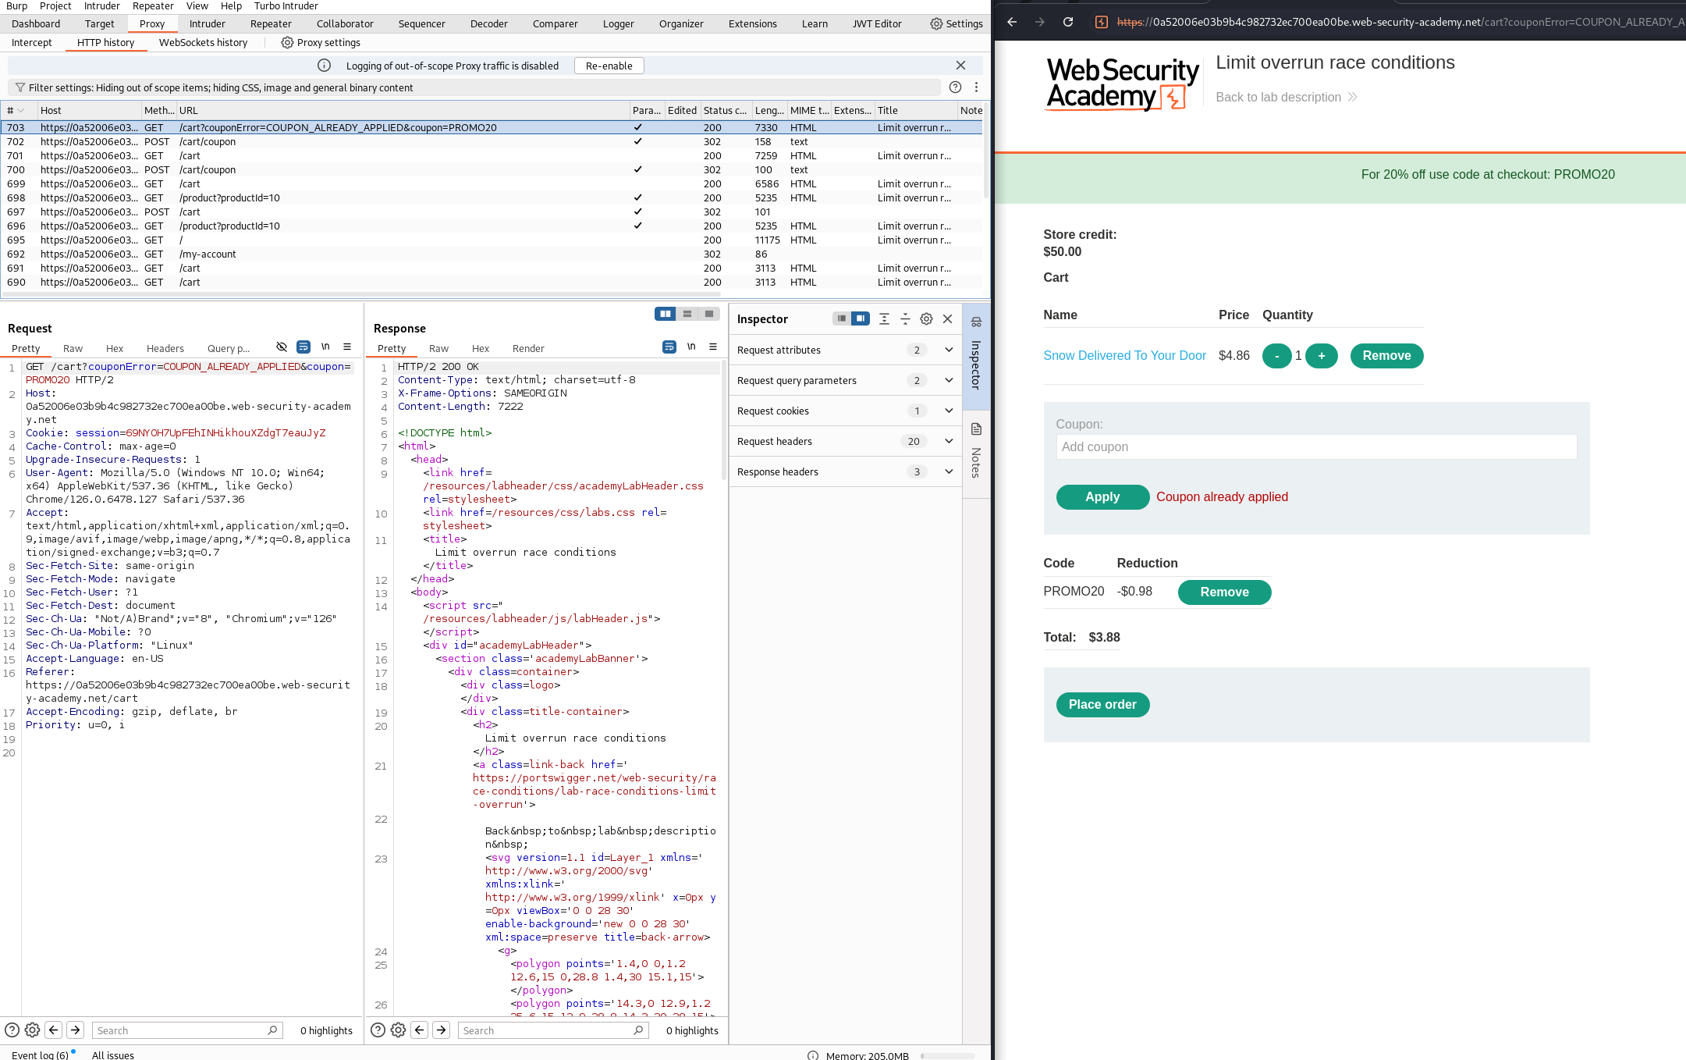

As you can see from the two screenshots above, simply trying to apply the promo code twice does not work. We can also see that removing our session cookie from the initial GET /cart leads the application to return an empty cart, meaning the state of the cart is stored server-side in your session and any operations on the cart are keyed on your session ID.
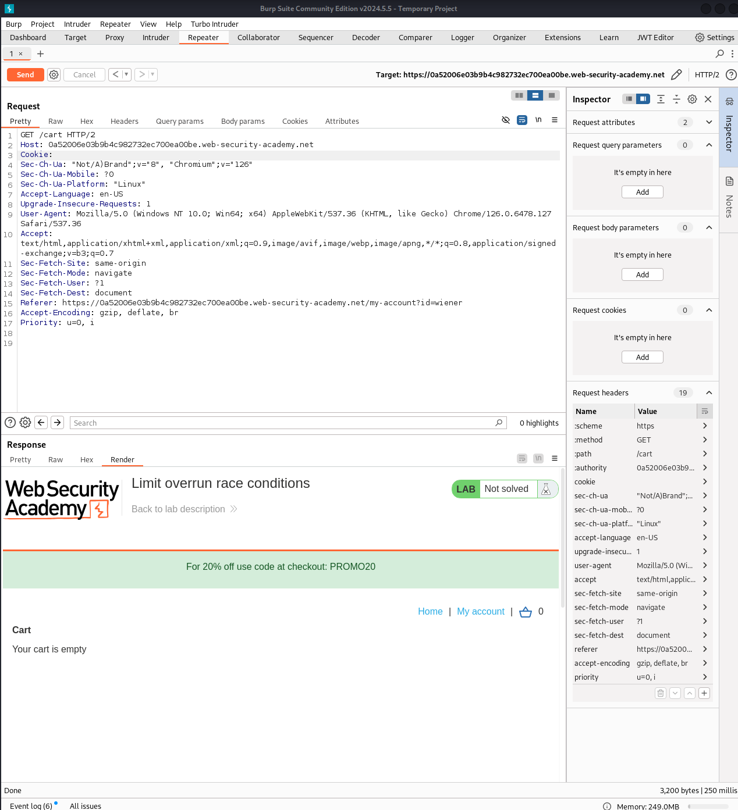
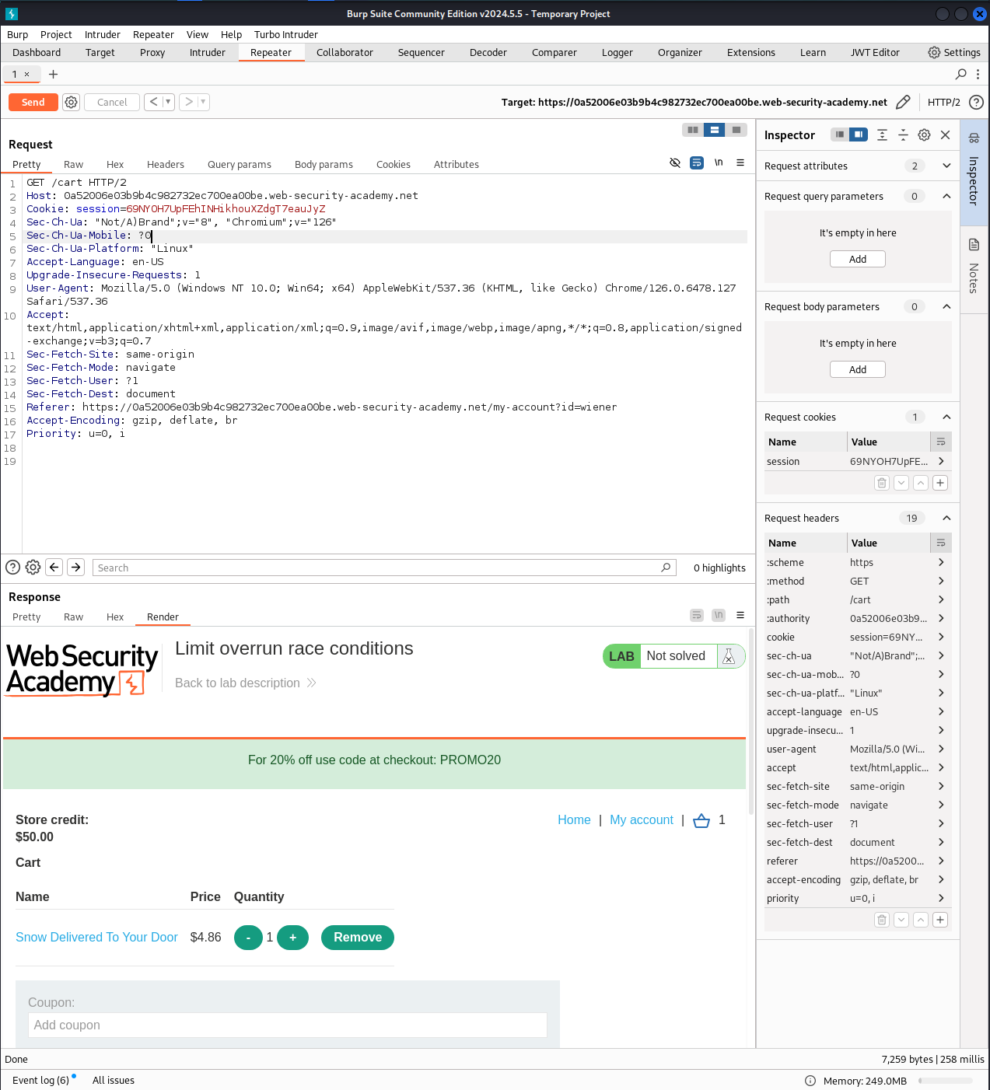

In order to try and leverage a potential race condition, we will have to use the Repeater tool to send multiple requests at once. First, we grab the initial request used to apply the promo code.

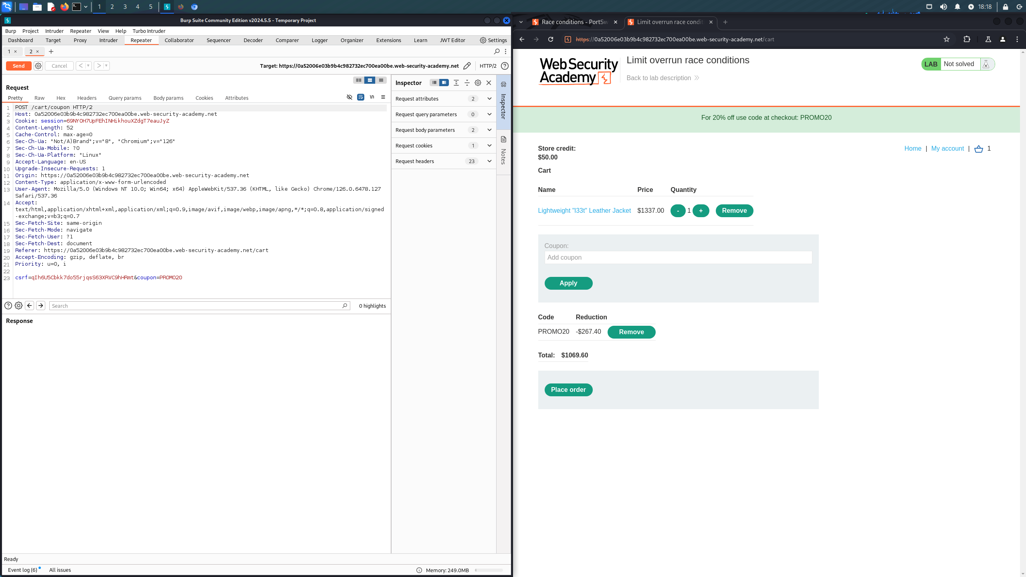

After removing the promo code, we create a group for the requests and duplicate it 99 times to send out 100 total requests. When sending them out, we send in parallel mode utilizing the single-packet attack method.

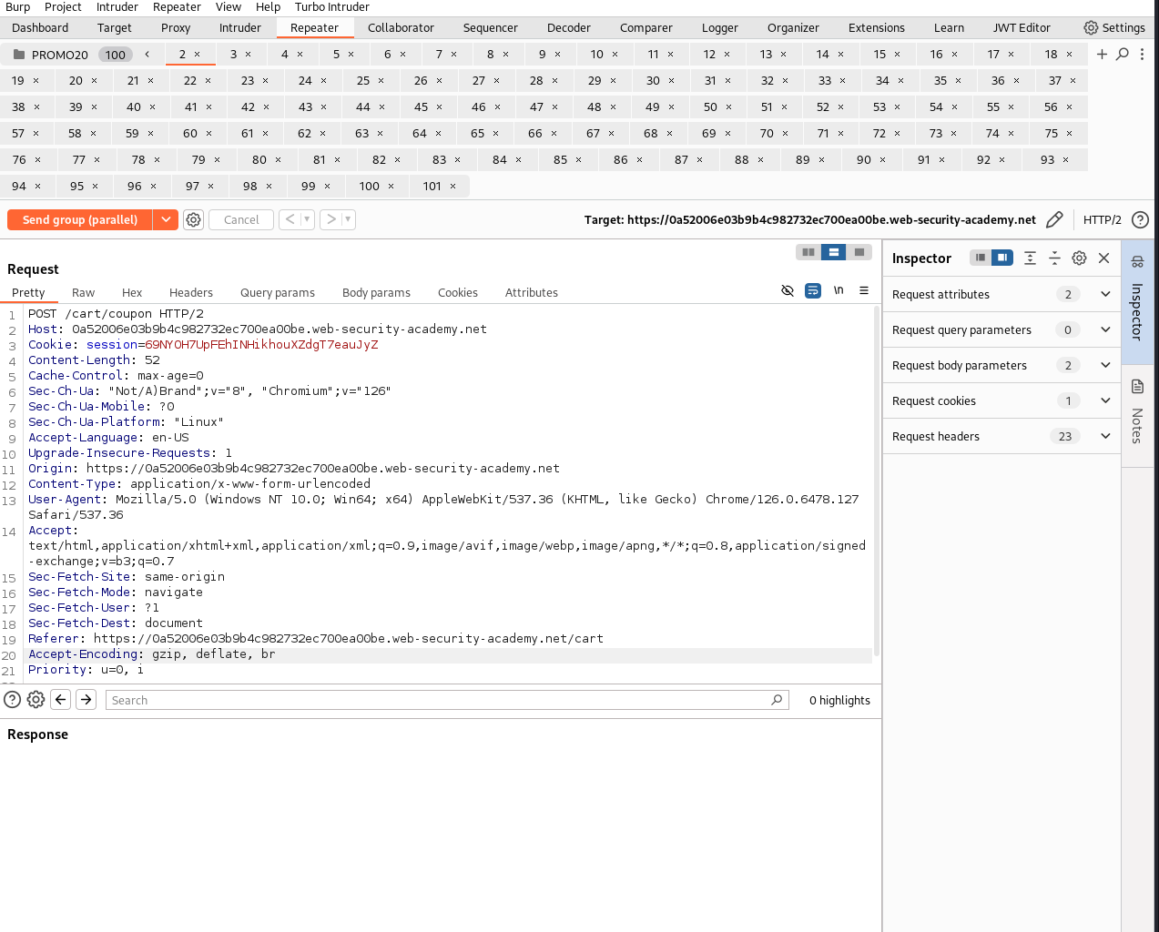

As you can see below, some requests do fail stating the coupon was already applied. However, enough succeeded as the price of the jacket is now low enough to purchase.

